**Register your robot to Orchestrator**

**The following is a one time action, for each individual robot. It does not apply to High Density Robots:**

* Go to **Robots**and click **Add.**The**Robot Description** page is displayed.
* Copy the **Key**.
* Additionally, to take advantage of the High Density Robots feature, select the **Create another** check box.

Note: The **Create another** option enables you to add multiple robots to the same machine if the Windows instance allows it, i.e. if the Windows Server is used. For more information about High Density Robots, see [this article](https://robot.uipath.com/docs/about-high-density-robots).  
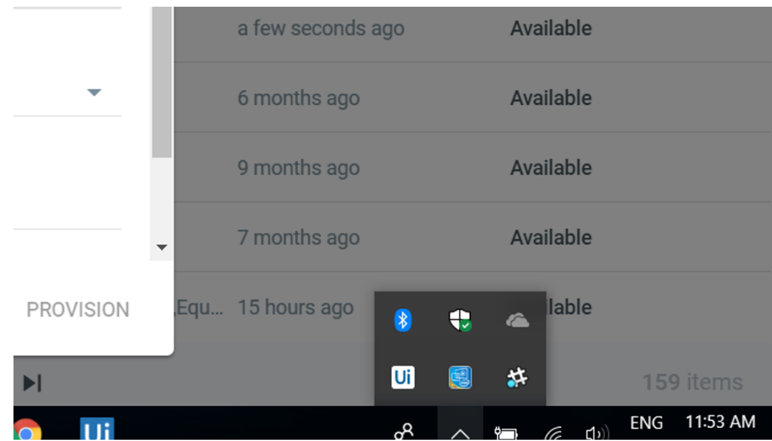

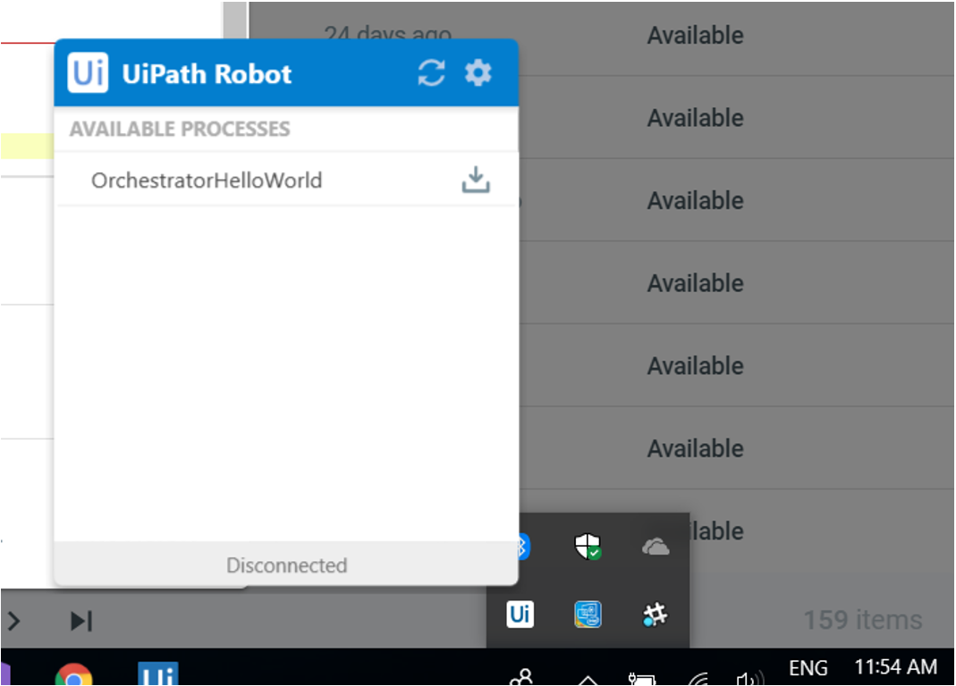

* Access the robot interface by clicking the**[UI]** Icon on the Taskbar. Select **Settings**. The **Robot Settings** window is displayed.

Note: If you can’t find the icon, make sure the service is running. [Click here](https://robot.uipath.com/docs/introduction) to see the instructions.

* Additionally, allow the robot to make changes if a window requesting that is displayed.

* Paste the key copied from Orchestrator in the **Robot key** field.
* Copy the **Machine Name** from the Robot Settings.
* Paste the machine name in Orchestrator, in the **Machine** field.
* In the **Name** field, enter a suggestive name that enables you to properly identify and handle the robot instance later.

Note: Make sure you follow good naming principles, to avoid robot mismanagement when multiple robots are added.

* In the Username and Password fields, enter the Windows credentials of your personal machine.
* Copy the Orchestrator URL and paste it in the **Robot Settings** window, in the corresponding field.
* In the **Robot Settings**window, click **Connect**.
* In Orchestrator, click **Provision**.
* Congratulations! The robot should now be visible under the **Robots**section, with the Active status.

